Mr Harry Williams
59 Centenary Avenue
Melton
VIC 3337
Harrywilliams2012@live.com.au
0413536469

7th February 2011
The Rudd government moved early and effectively to offset the impact of the
global recession on economic activity in Australia. We need similarly rapid and
effective action to prevent a re-emergence of sustained mass unemployment.
Time is running out.
Unemployment: the coming crisis
Professor John Quiggin ACTU Jobs Summit Pathways to Recovery 20 July 2009
NATIONAL COMMUNITY HOUSING DEVELOPMENT
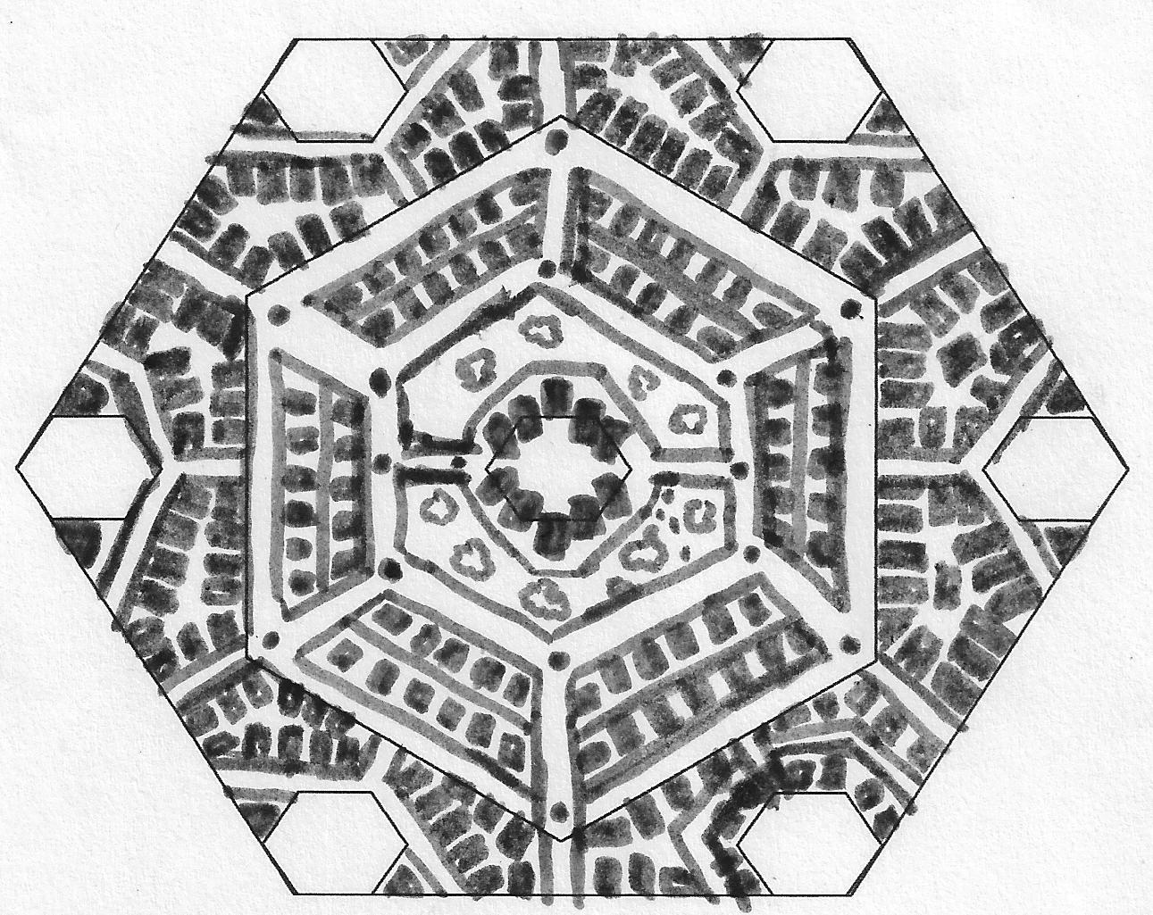

Executive Overview

Background
The Culture of the West and progressively the East, North and South have now what is deemed “sub nuclear families”. It is a microcosm of the culture that we are continually developing. The breakdown of the tribal or basic, extended, family structures and sustainable support networks in the modern ethics of our lifestyles and societies is in stark contrast to what has evolved from or more wholesome or holistic way of living. Historically the nucleus of people’s communities had Art as a major factor in expression and influence on the ones who serve or are subject to the communal principals of living. A positive impact to not only the artist but for the Patrons as well as whoever connects with what has been demonstrably expressed. Our everyday experience is inundated with the way the media explains how life really is. Through the incessant repetitious conditioning of what we see, we are. The rules of engagement are determined by what we are continually told through the media. Primarily in Australia we are conditioned to believe in the “Australian Dream”.
Abstract 1:
Typically the Australian Dream focused upon ownership of a detached house (often single storey with a solar hot water heater on the roof) on a quarter acre suburban block, surrounded by a garden, which featured in the back a Hills Hoist and a barbecue. Notably, this mirrored the fact that while almost 50% of Australian households owned their homes through the first half of the century, the proportion jumped to more than 70 per cent in the 20 years after World War II. While many Australians saw home ownership as a domestic ideal to aspire to, artists sometimes viewed it as representing a deadening conformism and narrow-mindedness—a critical perspective advanced by Brack's bleak images of uniform box-like houses surrounded by almost identical gardens, as well as Johnston's literary depiction of a rigidly uniform suburbia where neighbours try to police one another's behaviour. (http://en.wikipedia.org/wiki/Australian_Dream)
Multi million even billion dollar success is what we are inspired to work towards. Thus economic rationalization is seen as an attractive commodity in today’s western society.
As we come to terms with the grip of depleting limited resources and expanding populations. What is true of today’s culture is that we use and acclaim the resource and acquisition of money to qualify and quantify our success in terms of sustaining a status of achievement. Critically the world stock exchanges treat us human beings as an investment or capital in the empires of trade. The expenditure of human life is cheap as the bidding of those who have and desire more in the desire of power for the balance of control and management of international, national or common resources. The gap between the rich and poor widens.
Contrastingly there is no gap in how most are born into this world. It does not require money to have sex but rather a natural coming of age to procreate. Our societies today take the basic miracle or magic of conception and turn it into a commodity. The “Baby Bonus “ strategy of the Australian Government to produce a rise in the birth rate of our nation has accelerated and compounded social issues that must be addressed.

Abstract 2:
“Although there is no doubt that in many parts of the world, the extended family is still the norm, it is a norm which is in the process of dissolution. Indeed, in North America, Europe and even in parts of Asia, the new face of the family is small, nuclear, or even sub nuclear! In California, for example, where I lived recently for five years, serial monogamy, single parent families and similar anomalies seem to be the rule rather than the exception. The pressures of modernity, the changing role of women, the quest for affluence the emphasis upon individuality, and a host of factors have seen to that. Although no one would deny that the extended family is not altogether without problems: internal conflicts, exploitation and the like. The small or nuclear family also doesn’t seem to be any more satisfactory. In fact, the modern nuclear or sub nuclear family has created a multitude of new social problems: the whole scale loss of traditional knowledge handed on from generation to generation, individual psychological fragility and increasing social isolation are just a few of the consequences that have emerged from the new forms of social organisation.
The question that presents itself now and would seem to require an urgent and pertinent answer is, how do we preserve - or maybe resurrect - the values that have made the family the foundation of human society since the beginning of time.” (Family. Dr Peter Della Santina http://peterdellasantina.org/articles/family.htm)
Centrelink has 6.84 million customers
Abstract 3:

“One-parent families are the fastest growing type of family in Australia, with 823,300 single families recorded during the 2006 census. The Australian Government expects this number to reach 1.2 billion by 2026.” (http://raisingchildren.net.au/articles/parenting_alone.html)

Abstract 4:

“As the world slides deeper into economic recession, rising levels of personal and household debt become more of a policy concern, especially when combined with increasing unemployment and high rates of separation and divorce. While most household debt relates to mortgage costs that are gradually paid off over time, British research has suggested that the quintessential ‘problem debtor’ is a young single parent living in rental accommodation (Balmer et al 2005). When relationships break down, couples usually divide their marital assets but most couples have few assets and considerable debts. Furthermore, the living arrangements, family responsibilities and earning capacity of separated mothers and fathers continue to differ substantially. “
(The ‘Quintessential Problem Debtor’? Mother-Led Households in Economic Hard Times,
Maureen Baker, The Australian Social Policy conference 2009. 22 January 2009. http://www.sprc.unsw.edu.au/media/File/Paper266.pdf)

Abstract 5:

“The economic plight of single mothers is well documented. We know that single mothers may be poor for several reasons: their progress in education or work was delayed to have children, they lost a source of income but gained child custody following divorce, they do not receive child support, or they receive discriminatory wages (Bartfield and Meyer, 1994; Cherlin, 1992; Rind, 1991; McLanahan and Sandefur, 1994). Establishing that single mothers are generally worse off economically than married mothers has prompted further research comparing the outcomes of children from these family types (Astone and McLanahan, 1991; Crosnoe et al., 2002; Thomson, Hanson, and McLanahan, 1994). It is believed that the economic circumstances of single parents are largely responsible for the differences in child outcomes.”

(Background, The Relationship between Poverty and Parenting among Single Mothers, Beyond Provisions:
The Relationship between Poverty and Parenting among Single Mothers http://paa2005.princeton.edu/download.aspx?submissionId=51266)
The Proposal:
To rationalize expenditure for the seed of sustainable development this community housing initiative addresses the needs of adequate affordable eco-housing for unemployed, pensioned, single parents , the homeless, the ageing population, eco cashed up housing marketeers and even the recently displaced populous in the multi expanding precincts to our blending cultures in Australia at present.
In its Strategic Plans it has the mechanisms to develop the individuals and families to become more self supportive. Thereby paying coffers back to the Government and Investment through supportive collective enterprises.
The ethos and the vision behind this initiative is, by its very nature, one of nurturing and development. Infusing the arts, industry, technology, sociology and the labour force in a very positive way forward. This initiative takes a step to raising the standard of living to many socio economically disadvantaged Australians and provides instant opportunities to skilled immigrants, refugees and the disadvantaged to experience the Australian Dream.
For the Governments and Commonwealth of Australia it gives the control and regulation of the intellectual property of the new energies industries and way of co-habitation towards a sustainable and evolving future.
The Eco Urban design celebrates and encourages sustainable eco urban development pockets of inspiration and creativity and small business industries. This working model can be tailored and sold as a package to the world market as a Clean Development Mechanism and Sustainability product to developing countries as part of the UN Kyoto Strategies.
It revitalises the “Have a Go” policy developed through the determination of our nations’ constituents by the endeavours and empowerment of our peoples as the mettle of our nation during former periods of great struggle.
It draws upon established philanthropic bodies and sustainable resources and mentorship programs within its greater community as well as generating trade by its very ethos.

The Requirements:
By determining specific economically, emotionally and or culturally challenged groups of our populous it offers an exciting and stimulating environment to develop the skills sets and talents and gifting of both the participants and their supported family members in a collective based model of common sense. It has the ability to infuse the diversity of the Australian multi-cultural populous by focussing on a common objective.
Its ergonomic blend in surrounding expanding or rezoned population areas provides the perfect continuum for the points stated in the Engineers Australia Sustainability Charter:

“Objectives for Sustainable Development

· Development should enhance individual and collective well-being
while maintaining the viability of the planet.

· Development should ensure equity within the present generation as
well as for future generations.

· Development issues and problems should be solved holistically and
proactively”
(http://www.engineersaustralia.org.au/da/index/getfile/id/8929)
The crucial responsibility of Government is to act, as in “Act.. To take action”, on the reports at the forefront for community development and to act for a sustainable healthy future for all Australians.
“The costs of strong and urgent action will be less than the costs of inaction.”
(Sir Nicholas Stern, former chief economist of the World Bank on the discussions of slowing climate change.)

The Methodology and Governance
The Evaluation of the Community Arts Development Scheme
Final report
September 2009
Improving health and wellbeing through social connection and the arts
VicHealth

http://www.vichealth.vic.gov.au/~/media/ResourceCentre/PublicationsandResources/Mental%20health/CADS/CADS_Final_for_web.ashx

This report from the Victorian Health Promotion Foundation’s Community Arts Development Scheme (CADS) is inspiring and accurately chronicled. This multi-disciplinary team of researchers with expertise in the arts, health evaluation, ethics and sociology and urban design are indeed among the finest people of intent in Victoria.

Within the results of this report is a masterful development of a matrix that ensures carefully and considerately crafted systems of analysis and outcomes and feedback that supports the framework of both Public and Private enterprise to benefit the sub division schema, the functions and segregated variances of all participants, as well as the extended populous of environments of communities it is developed in.
Inclusiveness is the one of the key cornerstones of this development. The community will have their own representatives from each cultural group of people housed and representation from the regulatory bodies and academic bodies that invest their resources into its maturation. The representatives will meet in the form of a community council on a cyclic and ad-hoc basis to address issues or developments that may arise internally and externally with the regulated governance throughout the community lifecycles.
There is a growing amount of qualified professionals seeking employment in their respective fields who at present find themselves either unemployed or working in fields that are not satisfying to equal their interests. Another objective of this initiative is to provide meaningful and purposeful employment for post graduates.

An Evolvement into Management of Resources:
Sub Development Companies who from across the states and territories which are recognised as among the highest rated in environmentally sustainable urban development are the only ones eligible to tender for this initiative. The funds in part for this initiative seek the Sustainability funds.
The Australian Government Science laboratories of the CSIRO and citizens of Australia and from other countries have pioneered marvellous energy management systems and other environmentally friendly technologies to sustain a natural, global, sociological turn towards housing with a low carbon emission footprint. For the Commonwealth of Australia, these systems and technologies and urban design already available and maturing in are the very things that will make up the structure of this development and future developments of its type.
“Our Environment”, in this paper, pertains to the climate in which we sustain ourselves and any living or created thing that we assume responsibility for.
Management of the socio-economic development of all Australians is a step towards to a collectively supported sustainable environment and the development of our urban cultures as a nation.
The Design:
Patterning Nature:
In our times of great upheaval in a single global consensus of what is actually occurring to the planet.
The development of the Meta Sciences reflects our interconnectedness with everything known about our universe and the deciphering of mythical concepts.
The architectural and land planning design of this housing development reflects simple patterns of these geometric elements and anthropological myths.
It also incorporates the use of space, the flow of air and the energy of light and colour to attract a sense of health and wellbeing to everyone who passes through or dwells in these spaces and places.
It promotes the protected, or sacred, cell psychology of rebirth and replication represented with the waste and water management, parklands and recreational spaces in its urban design.
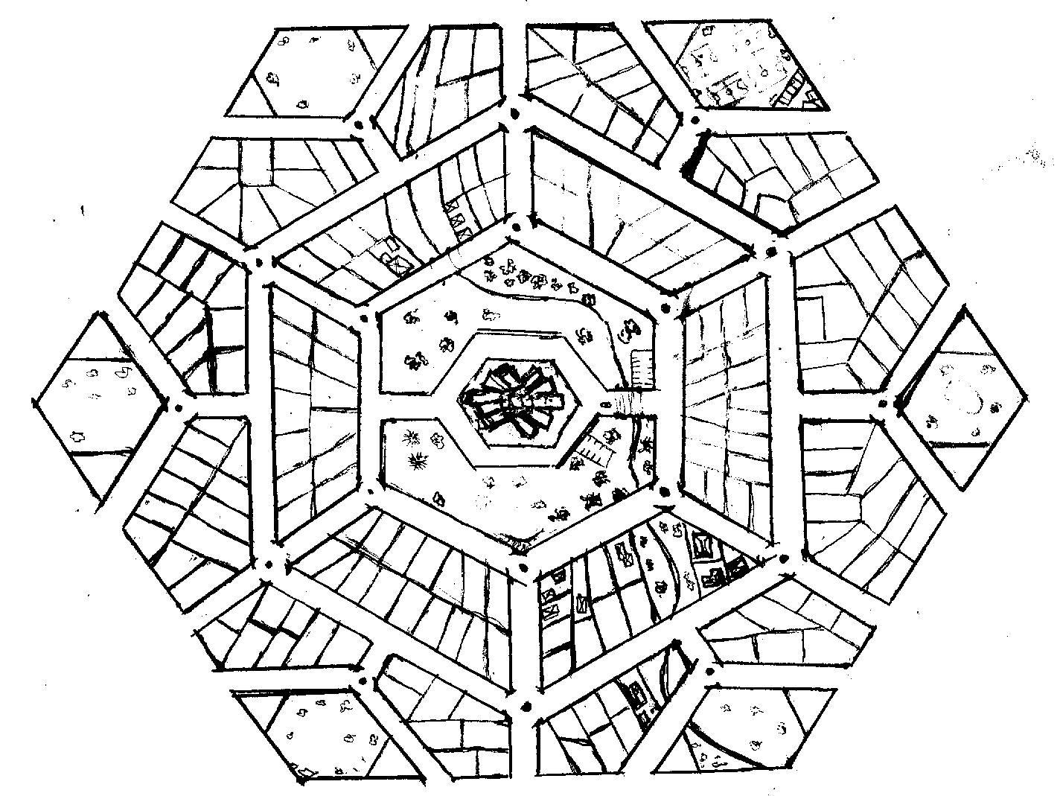
The return on investment is tiered. The Land parcels should have a 99 year lease and range in value as to function to the title caretaker. The public roads and spaces are offered to local council with the supportive maintenance of selective public housing participants in the middle and outer rings. Federally titled parcels are offered to the public housing sub developers to an initial 12% profit on development then a residual return from the State and Territories Governments through the expenditure and accumulative value on the title units that are constructed and rental purchased by the public housing participants.
Specific industry clustering of housing participants can be achieved by profile analysis of possibly well documented or entry screening information of public housing agreements. Scoping and screening through defining personal desires and historically placed work industries, including cottage or hobby or interest focused labour.

THE THREE RINGS OF GROWTH
The planning and design of this modular based concept for development places an intensity of focus from the central hub (or core enterprise) to the middle and outer urban rings. The outer and middle urban rings are also drawn to the inner ring as access to common land and community gardens thereby attention is drawn to the central hub to envelop it in community support and intention.
The uses and habitation of the rings have specific functions to invite and support to sustain a comfortable and thriving co-existence.
The Central Hub (Collective Enterprise)
The Inner Ring (Common)
The Middle Ring (Housing)
The Outer Ring (Housing, Businesses & Services, Recreation)

o

o Ring

This is not to scale and represents a design concept rather than an actual plan.
THE CENTRAL HUB:
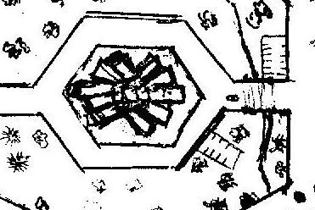
Clustered housing in an array of ten pointed star topology.
The Central Hub being run by the public housing participants who develop an enterprise and participants are assisted, mentored and monitored by the support team of specialists.
By giving of their time in part to labour they are collectively just as productive as the standard sole trader or partnerships of industries.
It is the centralization of supportive and communal energy that forges an intent to succeed.
Examples of an enterprise may vary. They could be a child care centre, a secretariat, a market place, an off site data storage facility, an arts centre, a café or restaurant, a nursery, a recycling workshop, an op shop, holistic therapies, a recording studio, a place of learning, a fabrication workshop, a mechanical workshop basically an enterprise where a viable business can service a need of a community or the greater communities.
Each Central Hub can be designed or fabricated with a specific need or service in mind. The accommodation spaces and the shared facilities surround the space of enterprise and the workspace is secure and not made readily available to the children of the Entrepreneurs. However young pre-school-aged children are readily at hand and have a support structure with the group as a shared responsibility.
Managing Anxieties through a Collective Courage:
To harness Industry and to be successful the emphasis is placed on the initiative of the participants by a collective of instinct for survival in commerce or trade which is characterised through the enterprise of the agreed business. Whilst availing time to support one another as a greater collective or extended family. And also avails time for self development and commitments of the participants to the enterprise and the support and training infrastructures.
This develops into a focus of ongoing sustainability and further future development.
Risks are minimalized by a careful developed pre-entry analysis of the intended occupants of the central hub complexes and specific framework of structure and support of industry specialists and sociological mentoring experts for coaching and training. Therefore all social and mental health factors are considered and pressure points are managed by the assimilative mix of character traits and cultural influences and individual personal development.
Scoping and screening is achieved through defining personal desires and historically placed work industries, including cottage or hobby or interest focused labour.
Suggested Central Hub Accommodation Design
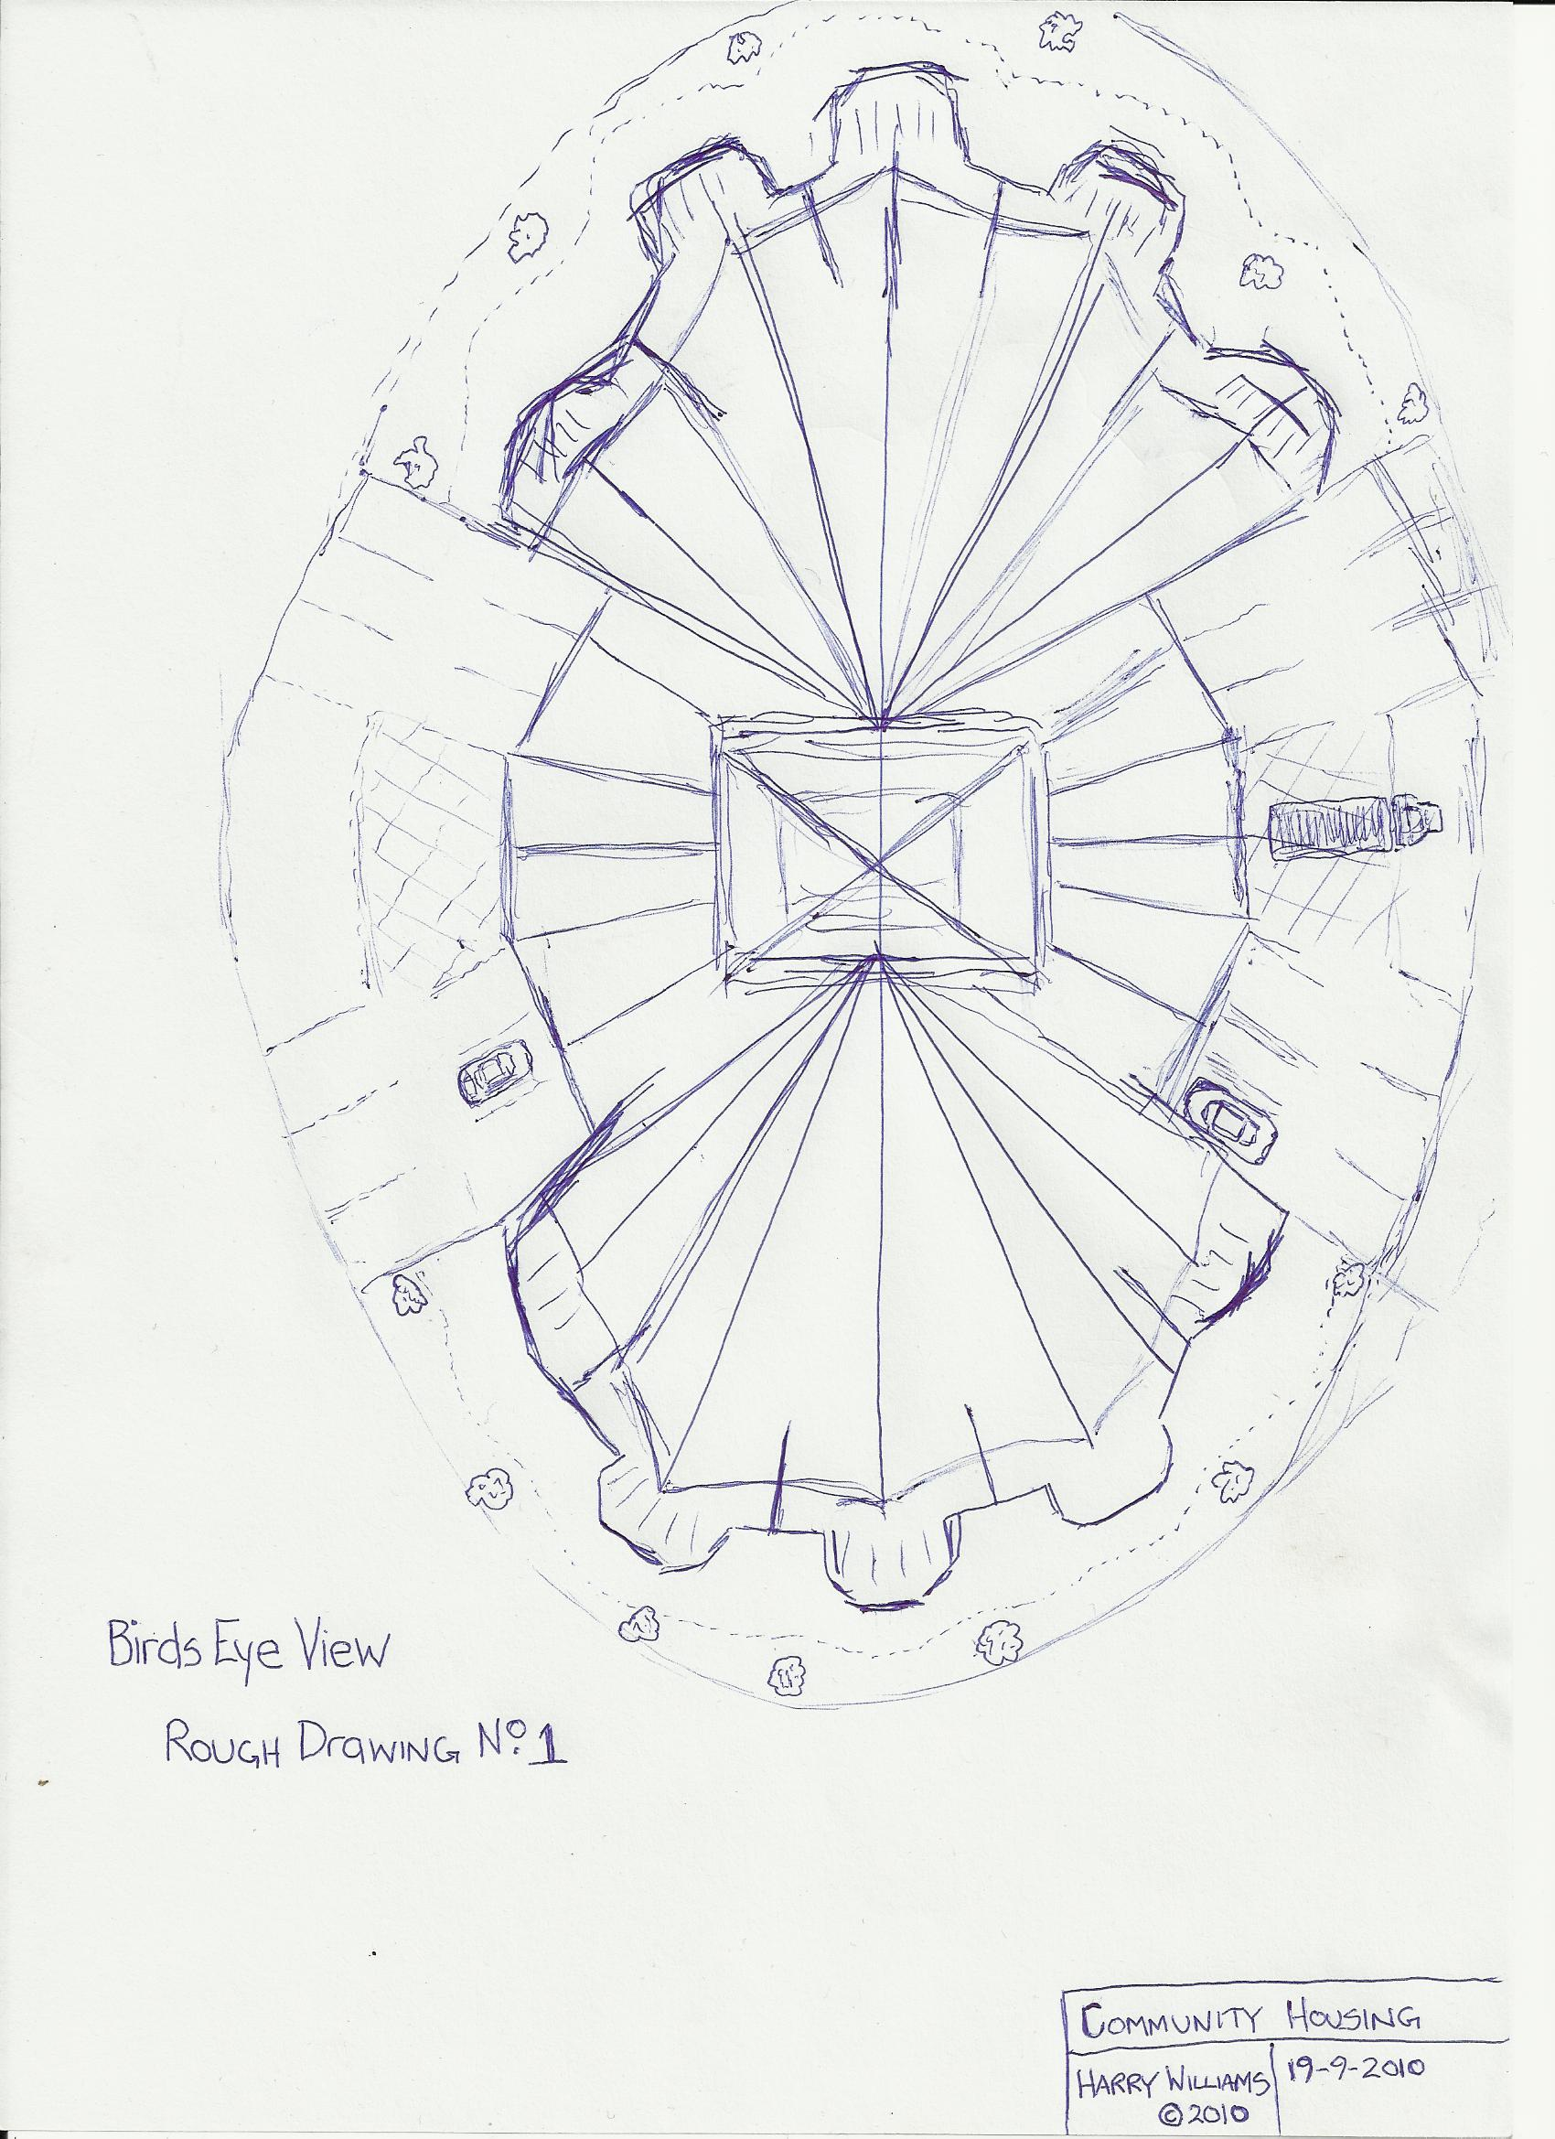
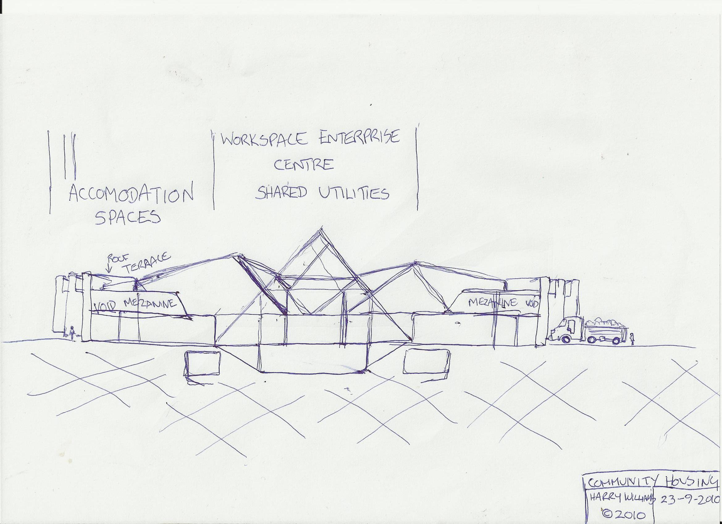

THE INNER RING
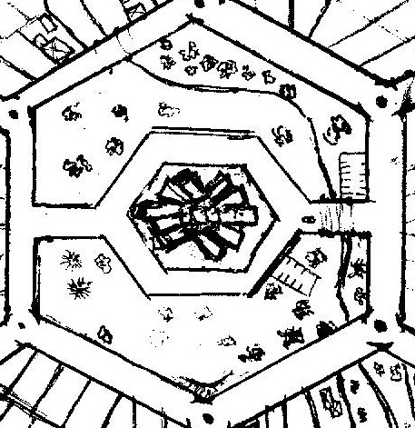
The Inner Ring on the surface is made up of parklands, water reserves, community gardens, public amenities and playgrounds.
There are also bunker mounds that access underground tunnels housing conduits of water, waste, communication media, energy, utility storage facilities and spanning the whole of the urban schema.
These services and their facilities are owned and managed by the Federal, State and Local Governments respectively.
The energy and resource systems are designed to not only optimise efficiency yet also create a revenue and through an excess of product to be on sold to existing Utility Corporations and metered through consumption providing a credit for the members of the subdivision.
Open air festivities and activities will be encouraged to provide added attractions to the community at large all year round. Thereby adding perspective and awareness to the celebration of the seasons of life and nature.

THE MIDDLE RING
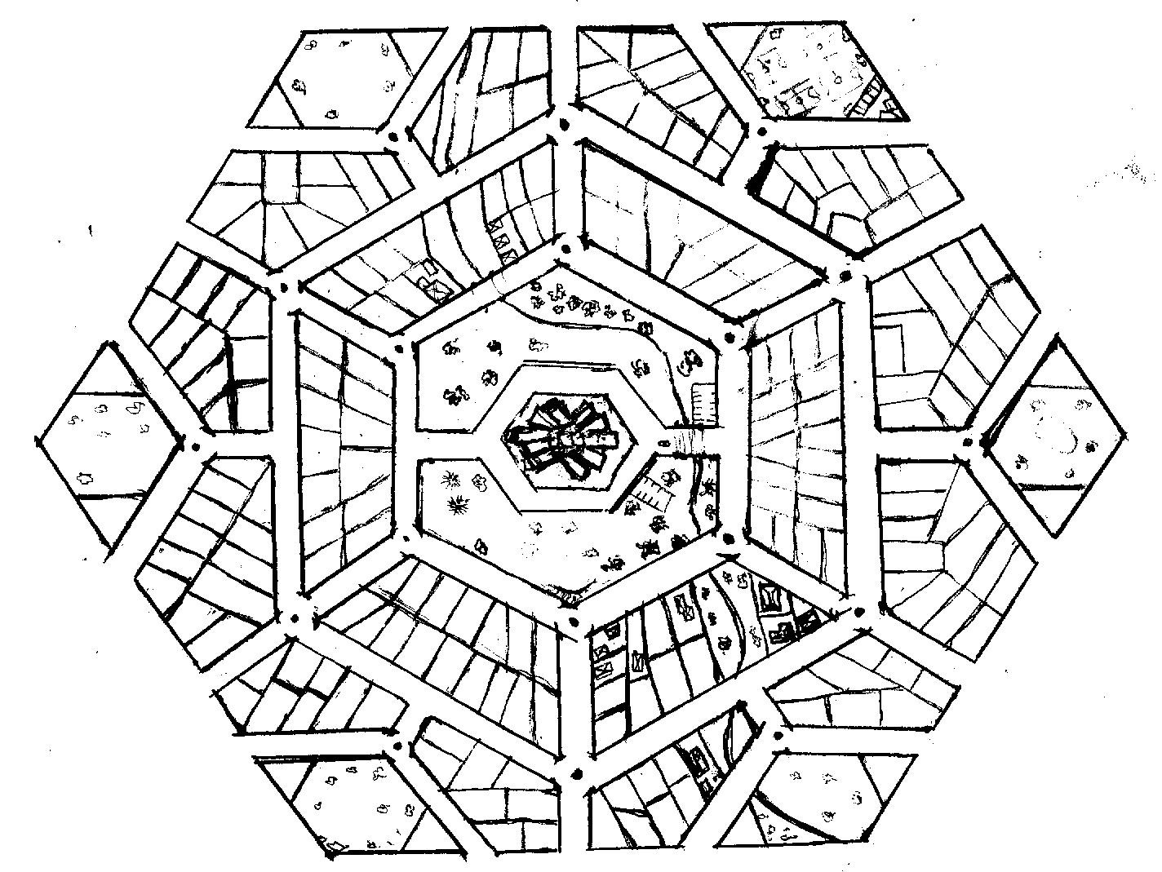
The middle ring comprises mainly of Private (70%) and Public (30%) Eco-Housing allowing easements for open natural water courses.
With the public housing properties a rental purchase is offered the residents plus part time or fulltime work to support the ongoing maintenance, support services, trades or businesses housed in and are contracted to support the subdivision. The conditional requirements are that public housing tenants must participate in paid work in some capacity to maintain the contractual agreement to live in the subdivision. These Public Housing tenants in the middle ring are generally single people so stratum titled lots are available for development. Aged care, retirement and acute care disability units also comprise of the allotment to the middle ring and would not be required to participate in work.

THE OUTER RING
The Outer Ring, allowing for easements of natural water courses, comprises of Private (80%) and Public (15%) Eco Housing and Retail and Business outlets (including Medical and Dental) (5%). The Corner Hexagrams offer Recreational Spaces or Complexes, Parklands, Community/Local Government managed allotments, Governance, Utility and Emergency Services.
Dual lane boulevards fringe the small sub-development producing honeycomb patterned thoroughfares through the precincts of the parcel of land that is being sub developed.

Each precinct containing its own microcosm of subdivision. Each central hub being of a different type of enterprise to its neighbouring ones. Parklands and services are plentiful and offer such a variety of options and facilities that would attract anyone choosing to invest in an eco friendly, sustainable lifestyle.
The above such example would accommodate approximately over 4000 dwellings. Sections on the outer rims could also accommodate industrial zones and a major shopping complex.
The whole subdivision would be bordered by main arterial roads. Public transport would weave through each precinct and transit transfer stations positioned on the arterial road infrastructure as well as offering express public transport direct to the CBD of the major city and other regional metropolitan centres.

Thank you for reading my proposal.

